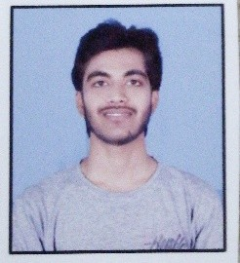RESUME

PRIYESH KUMAR SONI

+91 7354048849

Email Id: [soni.priyesh7@gmail.com](mailto:soni.priyesh7@gmail.com)

**OBJECTIVE**

To work with an organization where can learn new skills and increase my abilities for the organizational goals as well as myself.

**EDUCATIONAL QUALIFICATIONS**

* Pursuing BCA 3rd year from Indira Gandhi National Tribal University
* Passed out 12th from DAV SCHOOL Marks 80% from CBSE
* Passed out 10th from DAV SCHOOL Marka 86% From CBSE

**OTHER ACADEMIC DETAILS**

* Got 1st prize at Zonal level in National Science Olympiad.
* Got 1st prize at School level in Science Project.

**TECHNICAL KNOWLDEGE & SKILLS**

* Programming Languages

**WORK EXPERIENCE**

Fresher

**STRENGTH & HOBBIES**

* Hard & Smart Working
* Honest & Punctual
* Good Communication skill
* Dedication, consistency, Football, Movies

**PERSONAL DETAILS**

Father’s Name : Late Ranglal Soni

D.O.B : 03-01-2001

Address : H.no. 167, Old Pwd Office, College Colony, Burhar, Distt- Shahdol, Madhya Pradesh-484110

Marital Status : Single

Date ………………………. (Priyesh kumar soni)